North Douglas County Fire & EMS
531 S Cedar St. PO Box 277
Drain, OR 97435
Phone 541-836-2282 Fax 541-836-2292
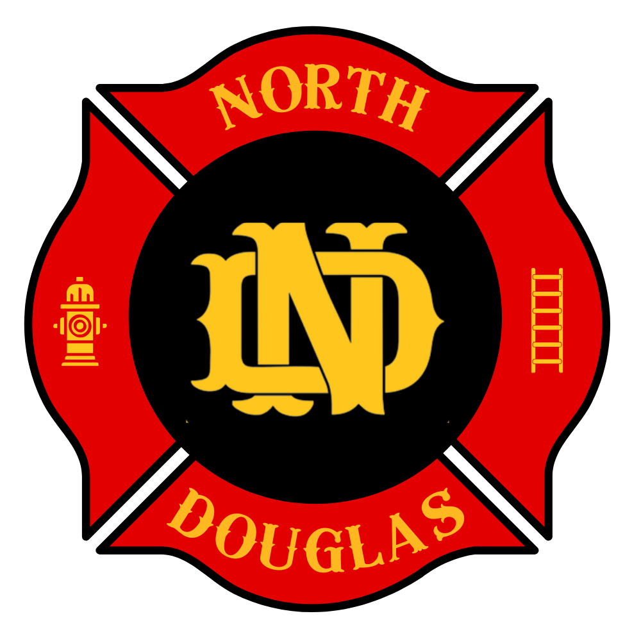

Meeting Sept 16th, 2024

Due to the lack of a quorum the meeting of the North Douglas County Fire and EMS Board of Directors was canceled. The next meeting will take place
October 21st, 2024.

Submitted by Sheryl Barrone

