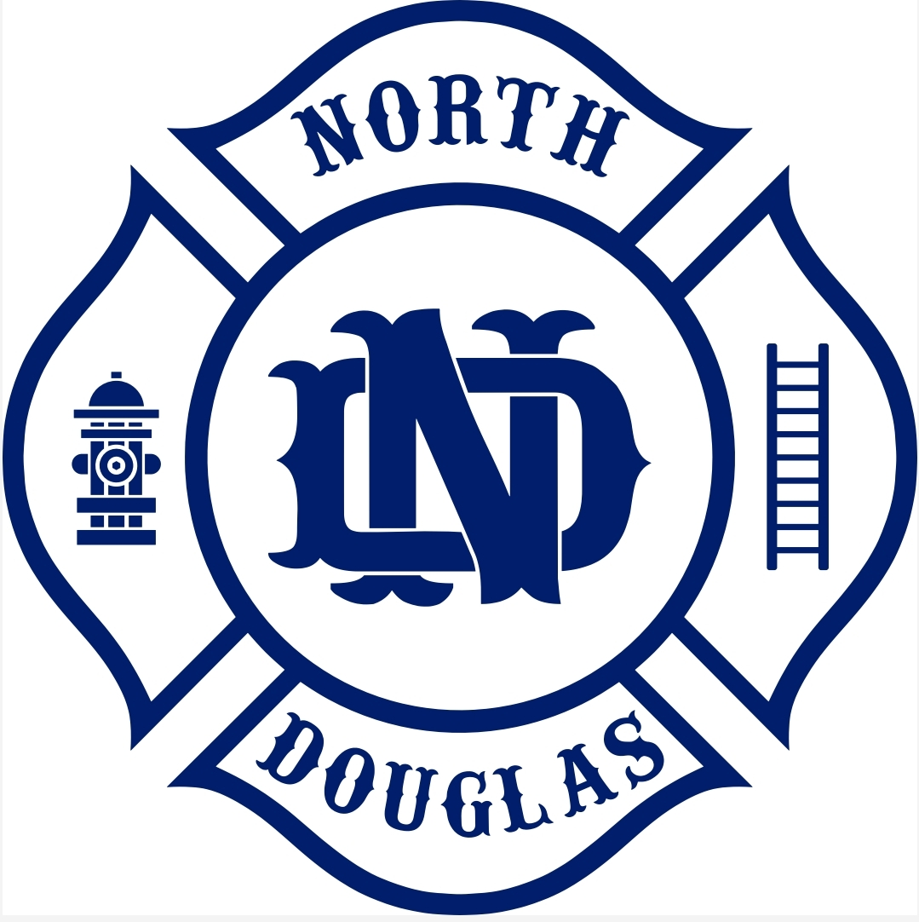

North Douglas County Fire & EMS
531 S Cedar St. PO Box 277
Drain, OR 97435
Phone 541-836-2282 Fax 541-836-2292

North Douglas Co. Fire & EMS
Budget Meeting-April 28th, 2025, at 6:00 PM
AGENDA

Call meeting to order.

Elect presiding officer (required) and vice chair (optional)

Elect budget secretary

Make budget documents available to all members.

Approve minutes from last meeting.

Chief Burke: Talk about the changes to the budget.

Receive budget message and proposed budget.

Approve motion setting the rate or amount of taxes necessary to balance budget. (1.2190+ LO .99)

Approval of the budget

